Kuril Chto
‘Goods’ exhibition
14.06 — 01.08.2022
Voskhod Gallery

Voskhod Gallery presents the first solo exhibition of the artist Kuril Chto – “Goods”. Creating graphics, paintings, objects, digital memes and urban interventions, the artist employs irony and the absurd to work with the themes of patriotism and the absurdity of the surrounding reality. His projects, whether they take the form of street actions, large-format paintings, or a sticker pack for Telegram messenger, are characterized by investigation into serious and often painful social issues via humor and paying attention to everyday life and the ordinary things that surround us.

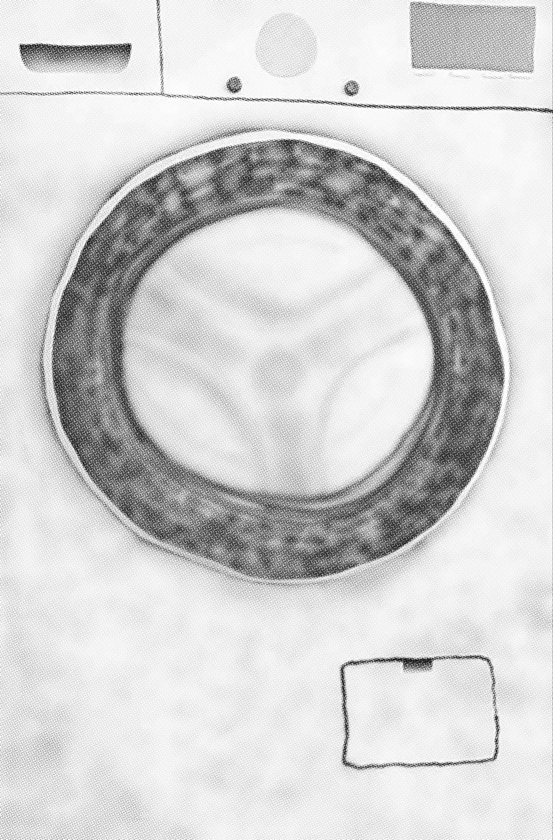

Looting has lately become the illustration of the outrageous and incomprehensible suffering of the Ukrainian people caused by the actions of Russian war criminals. The peculiar variety of looting that has emerged during the brutal attack on Ukraine may be characterized by Russian troops’ theft of basic household appliances and items – from washing machines to musical instruments, building materials and even cosmetic samples.

“The banality of evil”, mindless obedience to laws that are not simply inhuman but directed against the very foundations of life, were taken by Hannah Arendt and set in opposition to critical thinking, the only effective way to resist universal evil. According to the German philosopher, evil is committed by ordinary people who accept the order established in society as the norm and conscientiously fulfill the obligations assigned to them by the law currently in force. But what to do when the concept of a norm is determined not by the criminal code or ethical precepts, but by TV propaganda and the logic of narcissistic imperial authoritarianism?

Videos of Russian soldiers plundering grocery stores and civilians’ homes and sending the pilfered goods home to their families may be found all over the Internet. The most influential press organs all over the world, including The Times and The Guardian, have published revealing articles with photographic and video evidence, eyewitness accounts and the testimonies of those Ukrainians who returned home to find their houses and apartments plundered and devastated. Looting Russian soldiers became the topic of Reddit threads and memes involving washing machines and Russian soldiers have spread like wildfire online.

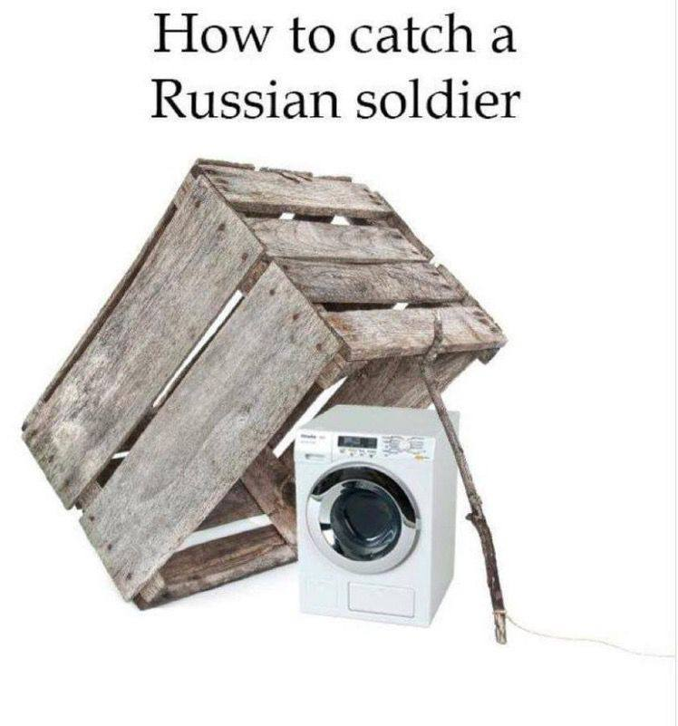
The artist Kuril Chto (literally “Smoked What”), who in his past projects has repeatedly turned to images of the typical household items that surround us in everyday life and shape our mundane reality, from chairs, ironing boards and indoor pot plants to head scratchers, has found a new hero: the washing machine that appears in a wide variety of forms, from painting on canvas and graphics to ceramic sculptures.

The washing machine has become, perhaps, the main symbol of the Russian army's invasion of Ukraine. For the soldier who has come to fight from the Russian countryside this is a luxurious trophy; for his relatives it’s a wonderful gift; for web folklore it’s a key image of the Newspeak which has appeared as a result of the “looting tour”; while for everyone else it serves an endless source of memes and jokes (the most striking of which involved helicopters flying at the Victory Parade on Red Square with washing machines suspended beneath them). What if, by means of the theft of this particular variety of household appliance, the soldiers of “unwashed” Russia are trying on a subconscious level to wash away not only the shameful stain on the entire army, but also the blood of those killed as part of the aggressive attack on Ukrainian civilians? By the power of the social unconscious, the washing machine turns not only into the paradoxical quintessence of robbery as a national idea and a sign of the imperial colonial consciousness or the desire to appropriate not only the territory of a sovereign state, but also the theft of the future from the younger generations inhabiting that country. With this artistic gesture, Kuril Chto puts washing machines on the same shelves as figurines of soldiers turned into commodities, the cannon fodder of propaganda and pawns in political games. The only thing that can unite them is not a national super-idea, but the desire to fulfill the need for basic household items and goods.

About the artist
www.kurilchto.com

The author, acting under the pseudonym Kuril Сhto, is a Saint Petersburg-born artist with a musical background, currently based in Lisbon. The artist works with various mediums: drawing, painting, applied art, digital memes, and urban interventions. At the present moment it is the intersection of contemporary folk art and DIY aesthetics that constitutes his key area of ​​interest, as this reflects better than anything else the new sincerity. He started his art career after a spell organizing music events, encountering art through his interest in urban aesthetics and street art culture. At the same time he was evolving as an independent artist, experimenting with his own style and exploring the techniques of naive art. He studied at the studio of Yelena Serebryakova. Until 2018 the main themes of his work were the innate lack of freedom, everyday militarism, and mockery of the stereotypes of contemporary art and the official government agenda.
In February 2022, Kuril Сhto received recognition from the Balenciaga brand following the publication of his art project “Balenciaga series”, being given an invitation to their winter show in Paris. The show was dedicated to the Ukrainian people and was also a highly personal matter for the brand’s creative director Demna Gvasalia – due to the fact that he himself is a war refugee.

Quotes from the author

“I chose street art because I saw and felt in it the maximum possible amount of freedom, courage, audacity and wit. The street art museum has become for me an island of freedom within the all-consuming authoritarian Russian system.”

“In the last years of my life in Russia I was scared because there was no true justice, because of the justification of primitive force, because of the normalization of cruelty on the public agenda. Living breathing people are tortured, raped, have their rights infringed, and this is passed off as normal. It's scary when people are afraid to say what they really think. They are afraid to fight for their rights. I still have terrible dreams where I am back in Russia and cannot leave. In my works I try not only to reflect reality, but also to express my disagreement with it.”

About Voskhod
www.voskhod.ch

Voskhod was founded out of Basel with two distinctive goals: Firstly, to engage a broader audience into understanding and communicating through art, while making the process of buying art more accessible. Secondly, to help talented young artists advance their careers and get more exposure on the international stage. To merge these two goals, Voskhod operates as an online art platform offering a fine selection of curated works from talented young artists. While the mission is to focus primarily on online sales through the platform, we are happy to leverage a small exhibition space in Basel to help connect with the local audience. The new display case is a relatively small exhibition venue (2.6 x 6m) that allows for compact exhibitions and shows and will help us to introduce our artists to the local Basel community.
We condemn the war that is now underway and we stand with Ukraine. We remain committed to supporting and nurturing our artists.

━━━━━━━━━━━━━━━━━━━━━━━━━━━━━━━━━━━━━━━━━
Part of the proceeds from the sale will be donated to ‘Ukrainian Refugees UAPT’, a non-profit organization based in Portugal that supports people seeking asylum as a result of Russia's war against Ukraine.
https://www.helpua.pt
━━━━━━━━━━━━━━━━━━━━━━━━━━━━━━━━━━━━━━━━━
The exhibition will open on Tuesday 14th June at 20:30 in the presence of the artist
Exhibition on display until 1st August 2022
Our public display cases are available for viewing 24/7
Voskhod Gallery, Post-Passage 9, 4051 Basel
━━━━━━━━━━━━━━━━━━━━━━━━━━━━━━━━━━━━━━━━━
Images
Press contact:
Tanya Pinchuk
+351 960 174 019
pgupsy@gmail.com
Telegram & WhatsApp + 79 218 810 545

